Task 1

My learning styles is read and write learning styles.

The most liked learning method is logic and mathematics because I like mathematic problem solving and we can improve our problem-solving skill, decision making skill and analytical skill in real life.

The least liked learning method is kinesthetic learning method because I have fear of failure in making discussing, presentation and other kinesthetic activities.

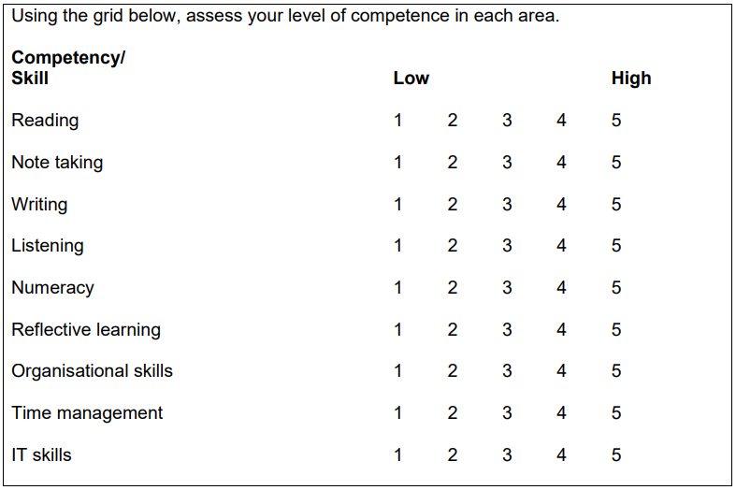



|  |  |
| --- | --- |
| skill | Action plans to develop |
| Reading | I have to make a reading habit every day. When I read, I will choose a moderate amount of material or a chapter to begin and read to end.  Read first for what you do understand and mark difficult spellings and phrases. |
| Note taking | I will listen actively in the class and practice note taking in different situations.  I think that using different colors in making highlight in important information is useful so I will try to use this.  I have a bad habit that I don’t review my notes. I won’t do that from now anymore. |
| IT skills | I am still learning IT now so I can’t use IT very well but I will take some course and certification. I will practice regularly during I am learning. |

|  |  |
| --- | --- |
| Skill | How I acquired or demonstrated |
| Listening | I always attend class regularly and listen to the materials what the speaker saying with my ears, eyes and other senses. Listening is taking time so patience is important and I’m always patience. |
| Numeracy | Mathematics is my favorite subjects. I have practice mathematical problem solving since I was a kid. Numeracy requires critical thinking skills so I tried to have critical thinking skills. |
| Reading | I have weak in reading so I will have to develop it. I will choose a moderate amount of material or a chapter to begin whenever I start to read. I will read first what I do understand and make spellings and phrases what I don’t understand. After reading, I find and note them. I always practice to read quickly. |
| Writing | I always practice writing assignments and essays. |
| Note taking | I have weak in note taking so I will have to develop it. I will listen actively in the class and practice note taking in different situations.  I think that using different colors in making highlight in important information is useful so I will try to use this.  I have a bad habit that I don’t review my notes. I won’t do that from now anymore. |
| Reflective learning | I always think about myself. What will I have to learn from my mistakes and I fix it. If I have a trouble in learning, I motivated myself and try try again until I success. |
| Time management | I use time usefully. I always attend class regularly and make a date book for appointments, meetings and group activities. I know what times of days are best for me mentally and physically so I always use these facts to plan my study time. |
| IT skills | I am still learning IT now so I can’t use IT very well but I will take some course and certification. I will practice regularly during I am learning |
| Organizational skills | I always train my organizational skills. I write ‘to do list’ for next week. Use social media and read news and data from websites. Collect materials what important for me. |